**Implementing a System to Improve Military Force Readiness and Decrease Disease Non-Battle Injury through FHIR/API/App System:**

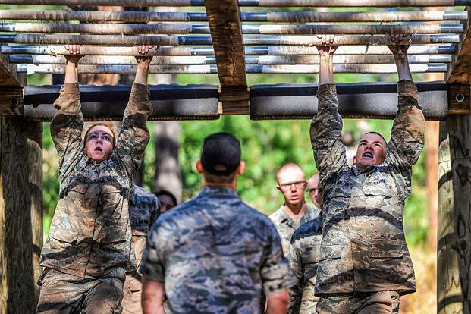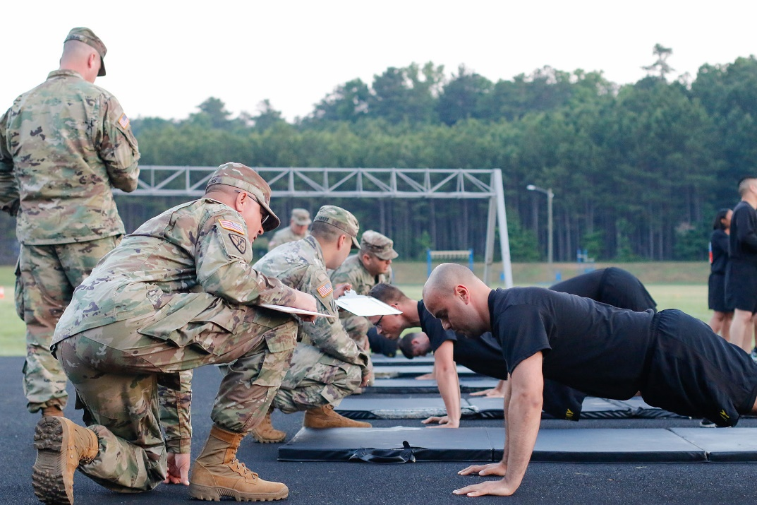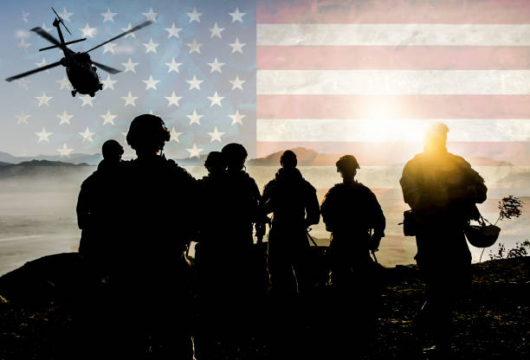

Currently, the United States military has participated in multiple oppositions to combat the Global War on Terror (GWOT), to make things more intricate, geopolitics have become very abrasive between the U.S, NATO, Russia, and Chinese forces. This means that there will be a direct correlation to an influx of service members ending up with disability in the future. However, the statistic remains that only a small percentage of service members see combat. Therefore, there must be other independent variables that are causing the large percentage of Disease Non-Battle Injurie(DNBI) rates that have been plaguing force medical and mental readiness. This paper will discuss discerning the cause of these high DNBI rates, gathering and interpreting collected data, how utilizing HL7 Fast Healthcare Interoperability Resources (FHIR) standards would improve interoperability, and propose recommendations to create solutions to combat the high DNBI issues facing our military and improve health data interoperability through an API/Application system.

The Department of Defense (DoD) has recently taken a data driven approach to cultivate better decision making at the operational level. This approach has led to the advancement in the DoD’s ability to aggregate and store data to be utilized for the military decision-making process (MDMP). This system, known as Advana, is the new advanced data analytics platform created by Booze Allen Hamilton®. Utilizing gap analysis, one can discern why there is a very high DNBI percentage of 30% facing our military even with the implementation of Advana and the Electronic Health Records (EHRs) system known as MHS GENESIS[1]. In this case Advana conducts data analysis of the health-related issues amongst the force and MHS GENESIS is known as the origin of the new electronic health record for the military health system. However, the health data is not sent to commanders at the unit level, the data is only seen at the DoD Headquarters Defense Pentagon. A current study in 2020, illustrates how DNBI affects medical readiness and the overall magnitude that improper training has on our service members, especially the Army and Marines[2].

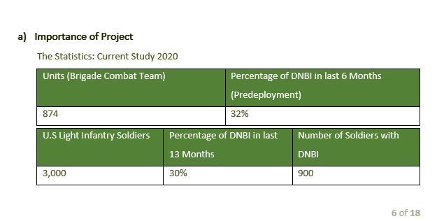

Gap analysis focused-on elements that were identified as problematic and may increase DNBI percentage**.**  Analysis identified the lack of communication/interoperability between service members EHRs and those making health related policies, the unit commanders that are training service members, and the physicians logging information into the EHR of the service member. There is a positive correlation between improper training methods and commanders not understanding what issues are causing service members to become injured in the first place, I.e., muscle skeletal injuries, disease transmission such as sexually transmitted diseases, mental health conditions that go untreated. If the commander of each individual unit is not tracking the causes of injury or illness amongst their service members, then how are these issues that are causing these maladies to be addressed? This is the main argument to bring interoperability and FHIR standards to commanders at the unit level.

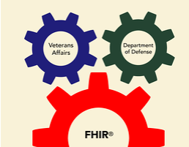

If one were to research this topic, there is plenty of information regarding FHIR being used for the VA, but not much on how FHIR can be utilized on active duty to become a force multiplier, allowing for commanders to make health data driven decisions to avoid unnecessary DNBI. Therefore, this paper proposes that the DoD implement an API that pulls data from Advana which gets its information from MHS GENISIS the EHR. This API will sync with an application that conducts data analysis from the EHR utilizing FHIR standards for each commander’s battalion/company and present the data in a dashboard that can give the commander an overall look at what is negatively affecting their unit’s medical readiness and causing DNBI (example below).

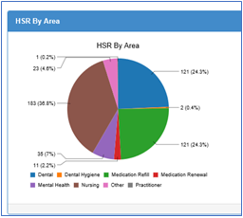

Injury Report by Area

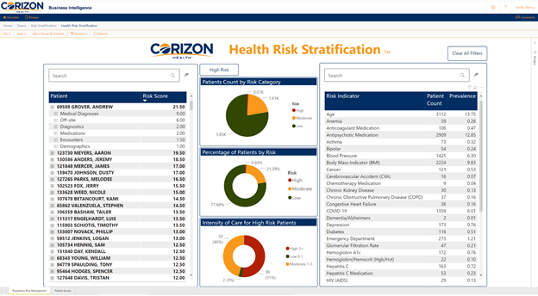

**Medical Readiness Dashboard**

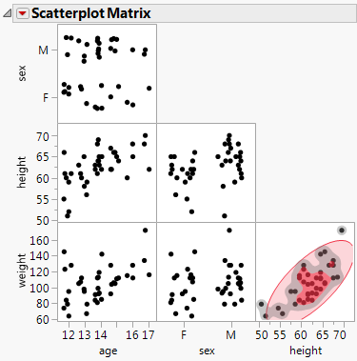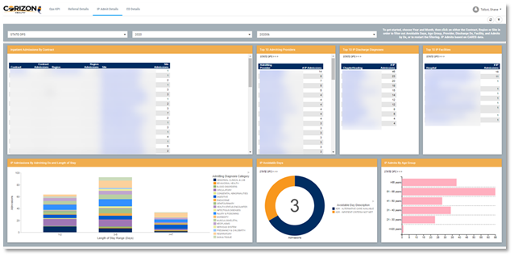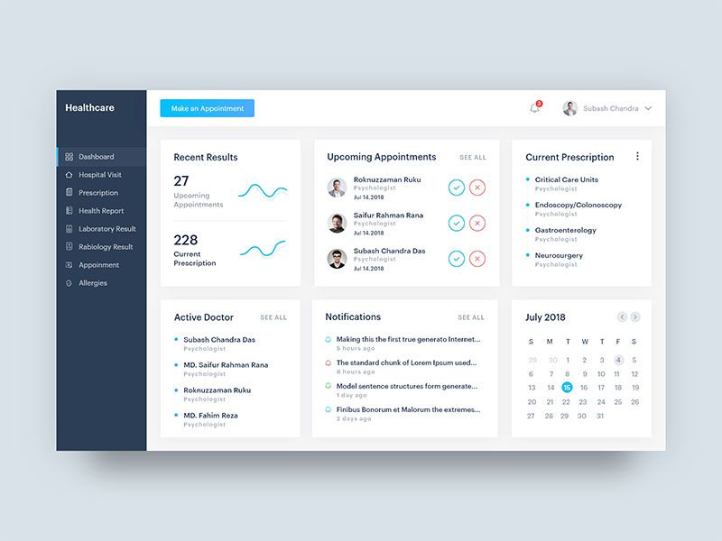

Relevant FHIR resources that would be utilized to adhere to FHIR standards would be “Condition”, “Diagnostic_Report”, and “Clinical_Impression”. This way machine learning (ML) and artificial intelligence (AI) through the data analysis application can evaluate through code by searching the “Condition”, what injuries were accounted for, i.e., when the injury took place, what part of the body was injured, and why the injury occurred.According to the HL7 FHIR website, “Diagnostic_Report” is logged when a practitioner, "requests" a set of "tests", the diagnostic service returns a "report" which may contain a "narrative" - a written summary of the outcomes, and/or "results" - the individual pieces of atomic data which each are "observations"[3].

AI and ML coded to recognize specific key words will then document those key words into data streams. For example, if a report reads, “service member fractured left tibia bone at Fort Benning, GA, running on hard concreate surface during physical training”. The analytical application using ML would recognize an injury of the tibia due to running on concreate (solid surface). Which would indicate that the unit may want to conduct minimal impact exercises or invest in better running surfaces to prevent an influx of musculoskeletal injuries.

It is important to note that while civilian hospitals use ICD-9 codes, military hospitals use codes adhering to the NATO Standardization Agreement (STANAG) 2050[4]. Although, FHIR compliments ICD-9 and ICD-10 codes, there might need to be tweaks made for the API/Application to work with STANAG. Having this technology integrated throughout the military units would most certainly decrease DNBI rates, which would decrease the burden of disease and injury on both the military and veteran societies. As of right now, there is not an integrated system that allows commanders to tap into health data to drive smart training. Adhering to FHIR standards would ensure that interoperability is maintained by the API/Application. The overall interoperability and data flow would be pertinent to the success of the application’s ML and AI software. The overall structure of the proposed system FHIR/API/App system can be seen directly below.

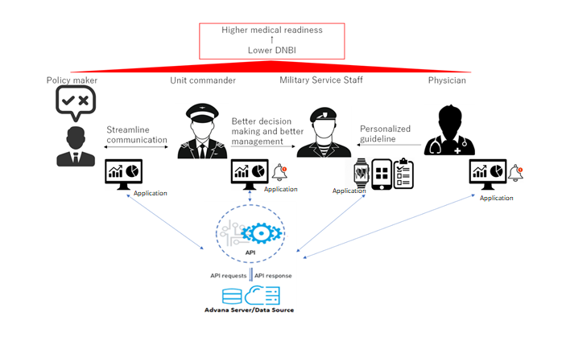

1. [Musculoskeletal Injuries and United States Army Readiness Part I: Overview of Injuries and their Strategic Impact | Military Medicine | Oxford Academic (oup.com)](https://academic.oup.com/milmed/article/185/9-10/e1461/5805225)
2. [Musculoskeletal Injuries and United States Army Readiness Part I: Overview of Injuries and their Strategic Impact | Military Medicine | Oxford Academic (oup.com)](https://academic.oup.com/milmed/article/185/9-10/e1461/5805225)
3. [DiagnosticReport - FHIR v4.0.1 (hl7.org)](https://www.hl7.org/fhir/diagnosticreport.html)
4. [Viewpoint: a comparison of cause-of-injury coding in U.S. military and civilian hospitals - PubMed (nih.gov)](https://pubmed.ncbi.nlm.nih.gov/10736553/)